M4H2: Intelligent Service Request Management
End-to-end lab flow
- Employee submits a request in Power Apps.
- Dataverse creates a Service Request row.
- Status becomes AI Processing.
- AI Builder analyzes the request and returns Category, Priority and Summary.
- Dataverse row is updated with the AI results.
- Power Automate evaluates business rules on the estimated cost:
  - Cost ≤ ₹10,000: auto-process, no approval.
  - Cost > ₹10,000: approval required.
  - Cost > ₹50,000: priority forced to High and approval required.
- Approver approves or rejects.
- Dataverse status is updated to Approved or Rejected.
- Employee is notified by email (optionally Teams).
- Power Apps displays the real-time status.

Business Rules Summary
Estimated Cost (₹) | Priority | Approval | Final Status (happy path)
≤ 10,000 | As assigned by AI | Not required | Auto Processed
10,001 to 50,000 | As assigned by AI | Required | Approved / Rejected
> 50,000 | Forced to High | Required | Approved / Rejected

Task 1: Create the Solution
- Go to make.powerapps.com and select the correct environment.
- Open Solutions > New solution.
- Display name: Service Request Management. Create a new publisher Service Request Management with prefix sr (the lab uses sr_ in column names; your prefix may differ).
- Save. All components below are created inside this solution.
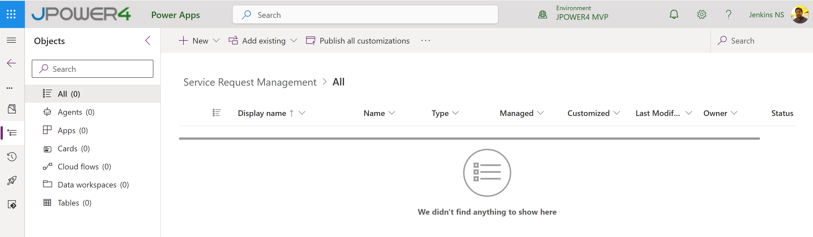
Task 2: Build the Dataverse Data Model
- Click New Table Tables
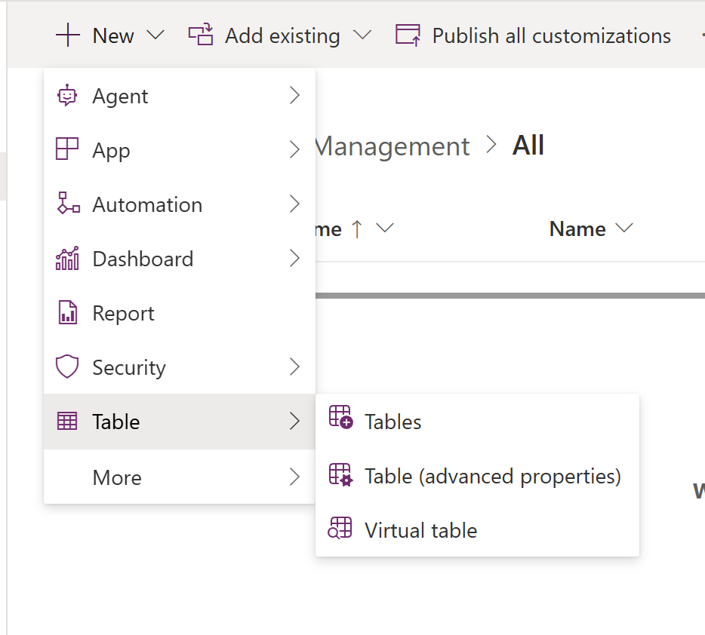

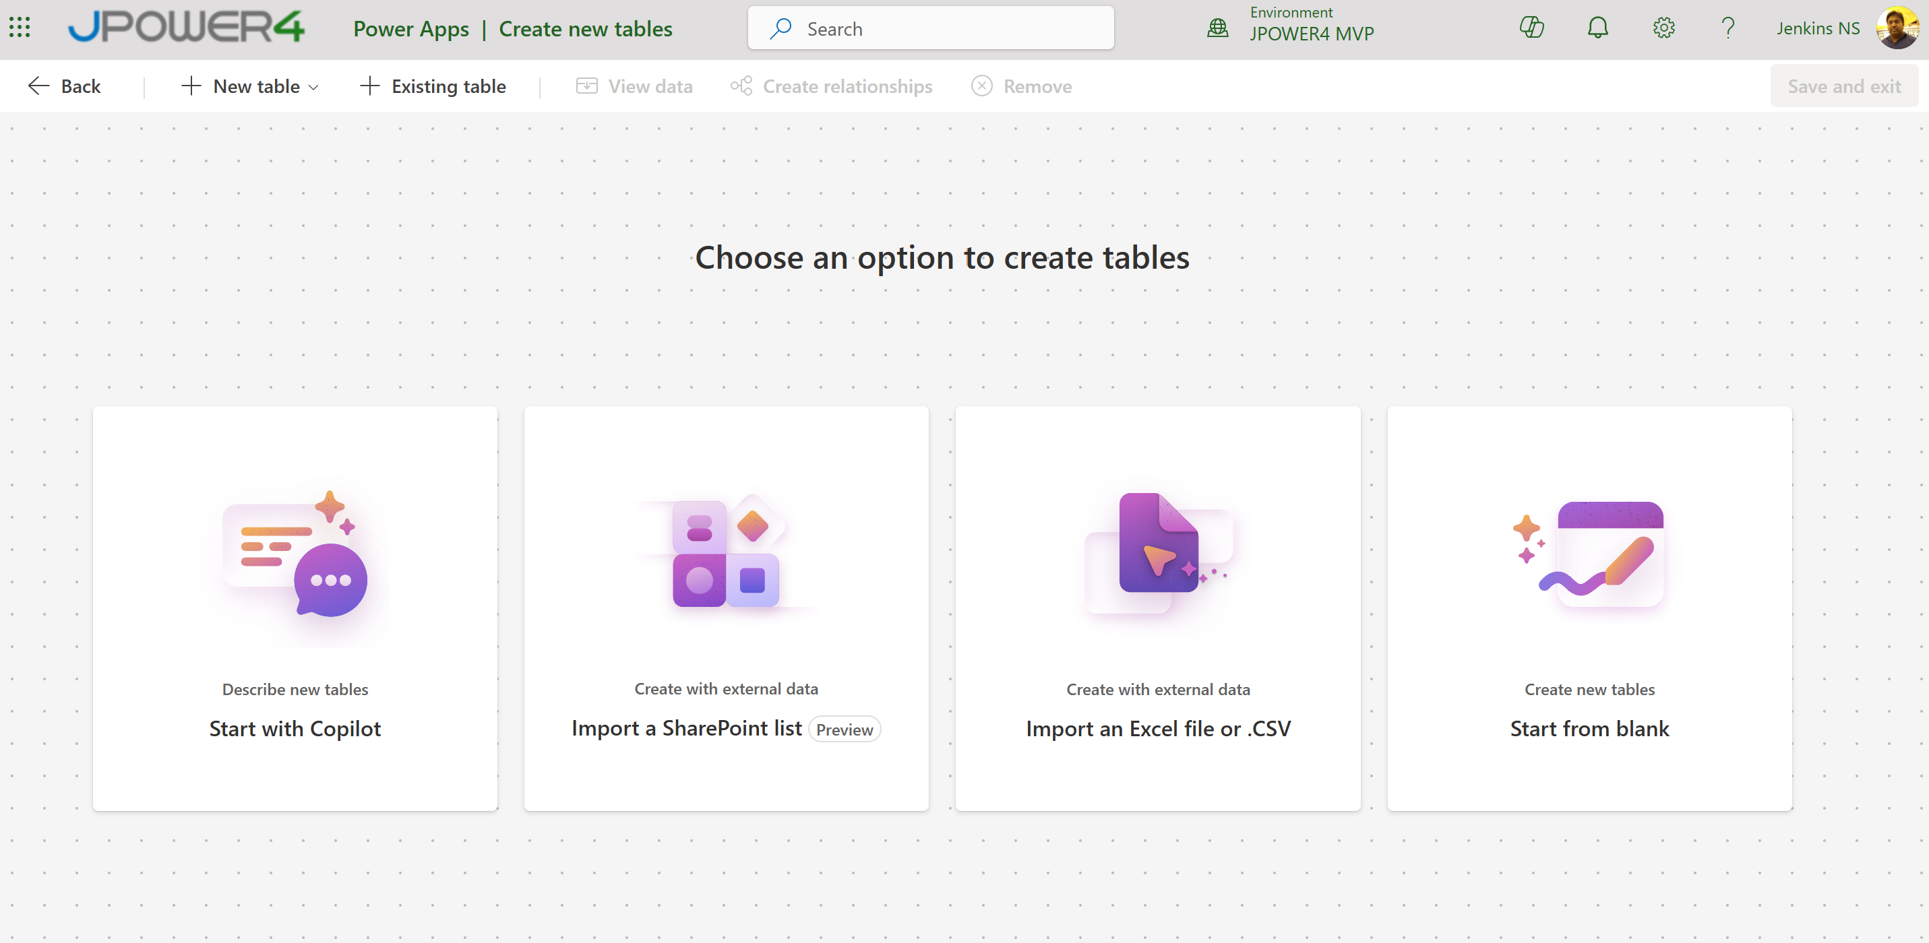
- Start with copilot
- Prompt to create a new Table
Create a Microsoft Dataverse table with the following specification.
TABLE
- Display name: Service Request
- Plural display name: Service Requests
- Primary column: rename to "Request Title" (single line of text, required)
- Table type: Standard
- Ownership: User or team
- Add the table to my current solution
COLUMNS 1.
Description
- Type: Multiple lines of text
- Purpose: Employee's free-text request
2. Estimated Cost
- Type: Currency
- Required: Yes
- Currency: INR
3. Category
- Type: Choice
- Options: Hardware, Software, Travel, Facilities, HR, Other
4. Priority - Type: Choice
- Options: Low, Medium, High
- Default value: Medium
5. Status
- Type: Choice
- Options: Submitted, AI Processing, Auto-Processed, Pending Approval, Approved, Rejected
- Default value: Submitted
6. AI Summary
- Type: Multiple lines of text
7. Requester Email
- Type: Single line of text, Email format
8. Approver Comments
- Type: Multiple lines of text

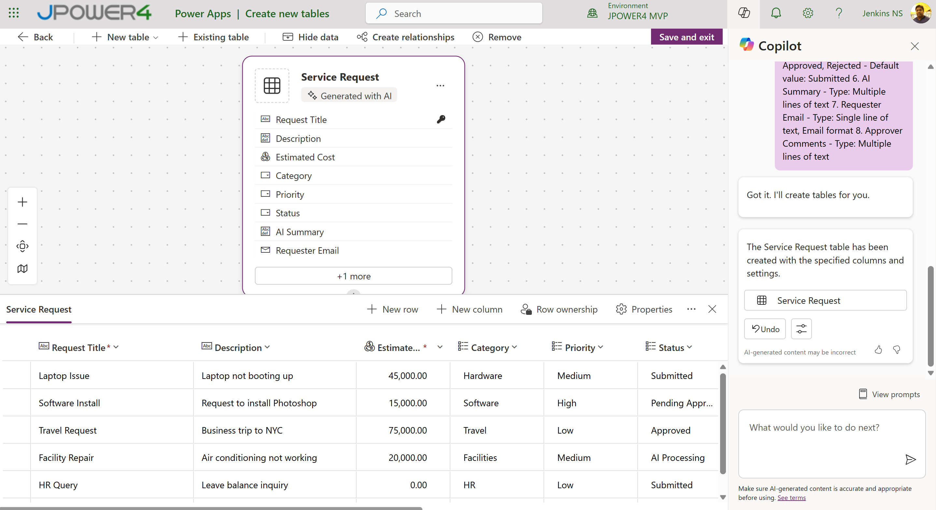

Task 3: Create a view and a form
- Create a view All Requests showing Title, Category, Priority, Status, Estimated Cost, Created On.
- Save and Publish

Task 4: Configure AI Builder
In this task you use an AI Builder prompt (generative AI) that reads the request and returns structured JSON. This replaces training a separate classification model and also generates the summary in the same call.

Create the prompt
- In make.powerapps.com open AI hub > Prompts > Build your own prompt.
- Prompt Name: Classify Service Request.
- Add two text inputs: RequestTitle and RequestDescription, and one number input: EstimatedCost. Provide sample values for testing.
- Paste the following instruction:
You are an internal service desk assistant for an Indian enterprise.
Analyze the request below.
Title: {RequestTitle}
Description: {RequestDescription}
Estimated cost (INR): {EstimatedCost}
Return ONLY valid JSON, with no markdown and no extra text, in this format:
{
"category": "Hardware | Software | Travel | Facilities | HR | Other",
"priority": "Low | Medium | High",
"summary": "One or two sentence neutral summary, maximum 40 words"
}
Priority guidance:
- High: blocks work for a team, safety or compliance issue, or urgent deadline
- Medium: affects one person's productivity
- Low: nice to have, no deadline
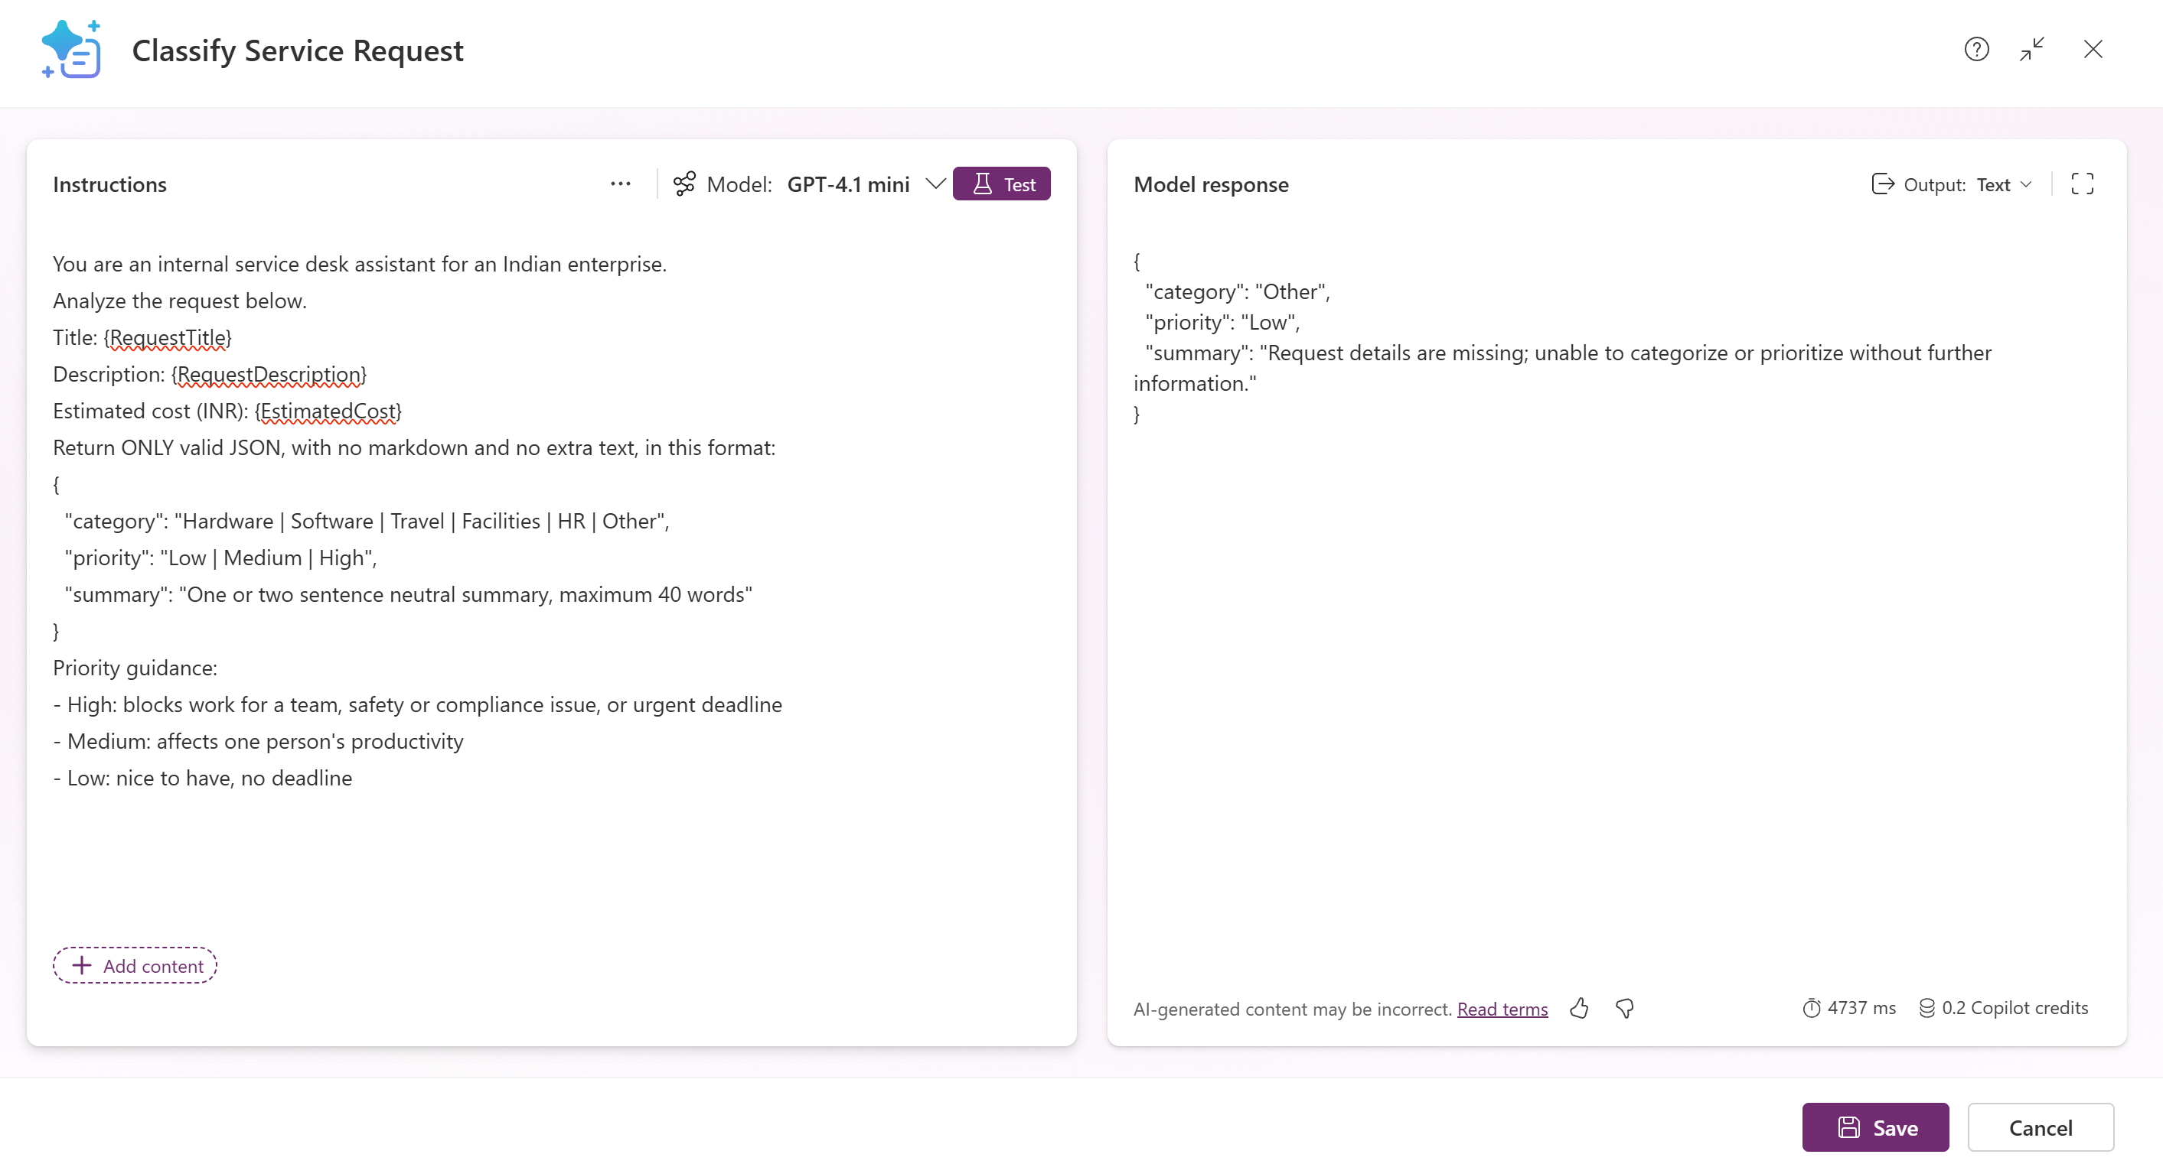
- Set the output to JSON, in the right-hand side
- Save the prompt.
- Use Test prompt with samples such as:
  - "Laptop battery dead, cannot attend client calls", cost 9,000.
  - "Annual Adobe license for design team of 12", cost 65,000.
Task 5: Build the Power Automate Flow (Business Logic)

Create the flow
- In the solution choose New > Automation > Cloud flow > Automated.
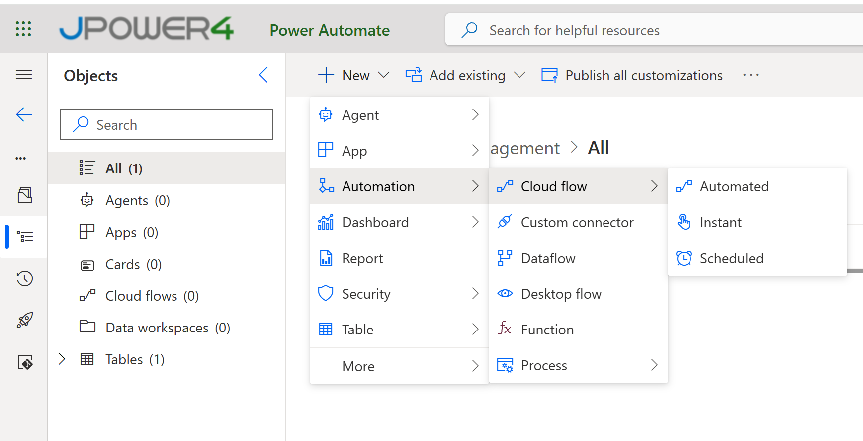
- Name: SR - Process Service Request.
- Trigger: Dataverse When a row is added, modified or deleted.
- Create
  - Change type: Added
  - Table name: Service Requests
  - Scope: Organization
Add new Step -> Add Dataverse Update a row:
- Table: Service Requests
- Row ID: the row's unique identifier from the trigger (Service request)
- Status: AI Processing
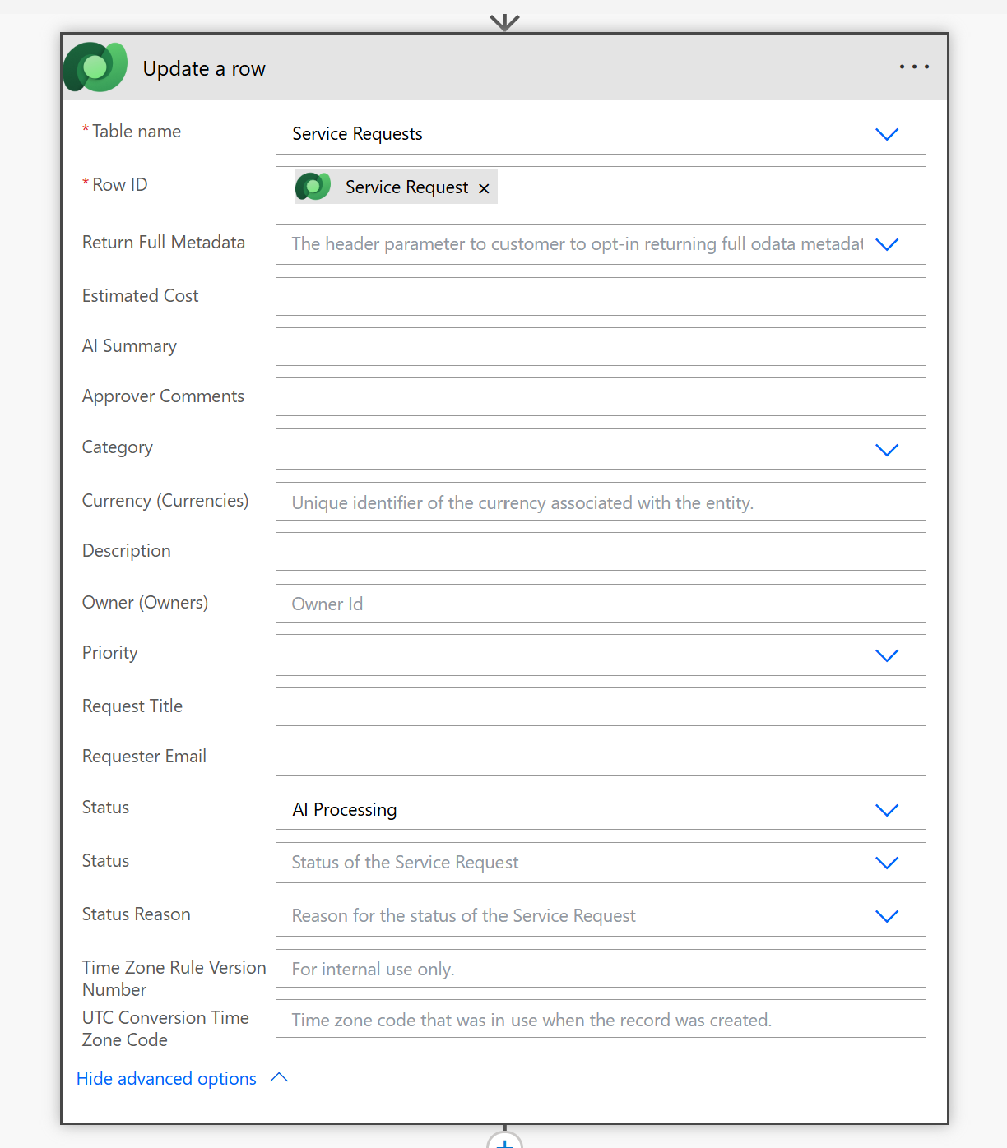
Next New Step Add the AI Builder action Run a prompt and select Classify Service Request.
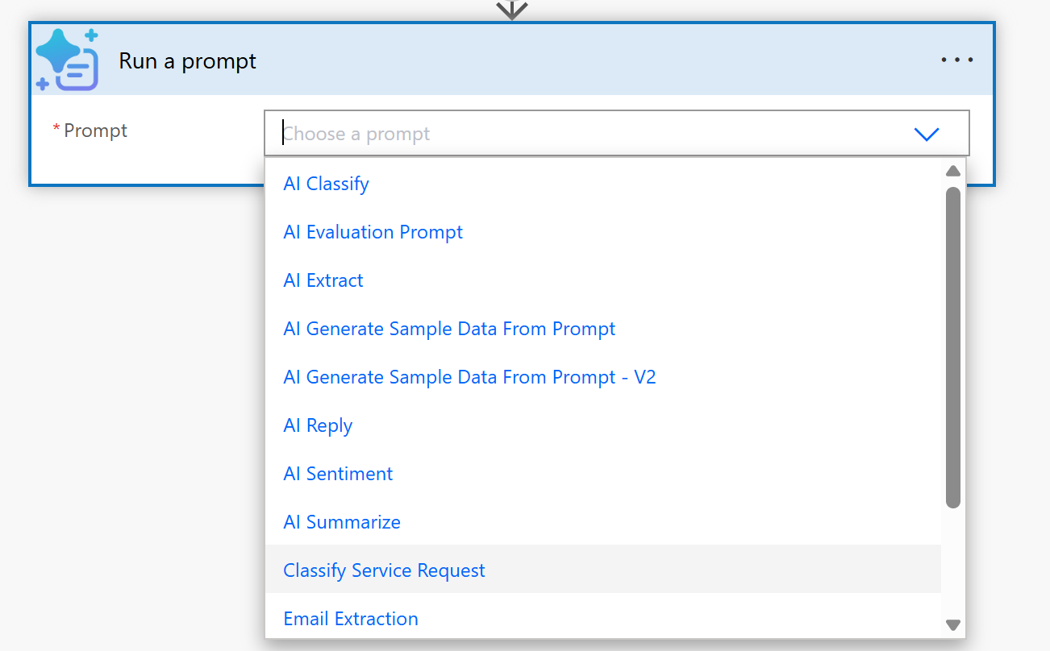
Next new Step Add Parse JSON with the prompt's text output as Content and this schema:
{
"type": "object",
"properties": {
"category": { "type": "string" },
"priority": { "type": "string" },
"summary": { "type": "string" }
}
}
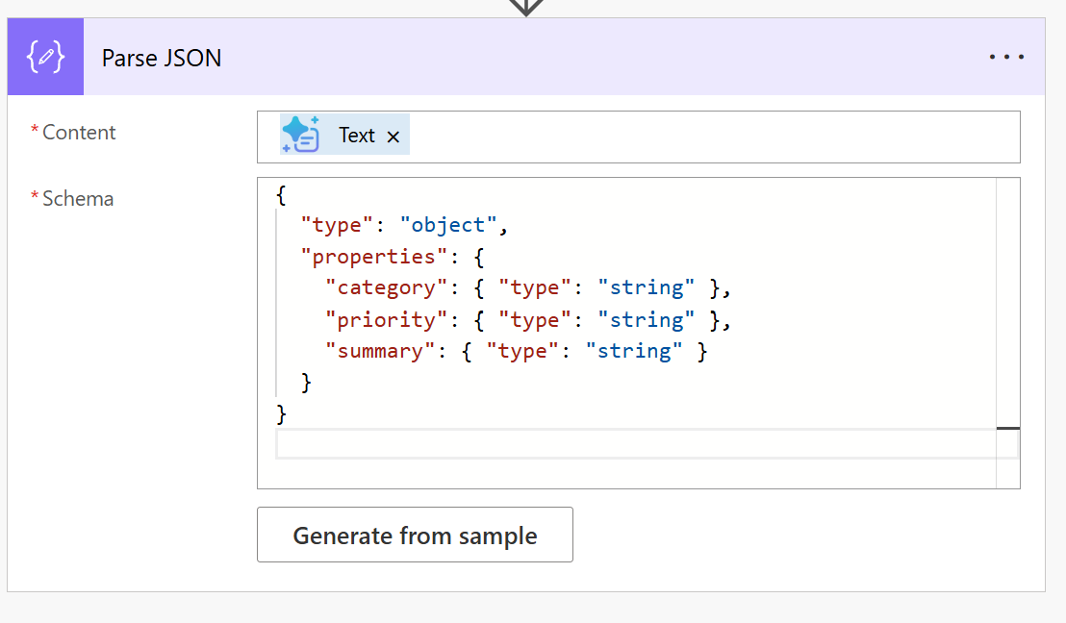
Next Step Add Update a row:
- Category: use a Switch or an expression that maps the text to the choice value, for example a Compose action:
if(equals(body('Parse_JSON')?['category'],'Hardware'),100000000,
if(equals(body('Parse_JSON')?['category'],'Software'),100000001,
if(equals(body('Parse_JSON')?['category'],'Travel'),100000002,
if(equals(body('Parse_JSON')?['category'],'Facilities'),100000003,
if(equals(body('Parse_JSON')?['category'],'HR'),100000004,100000005)))))
- Priority: same pattern for Low, Medium, High (use your own choice values).
- AI Summary: body('Parse_JSON')?['summary']
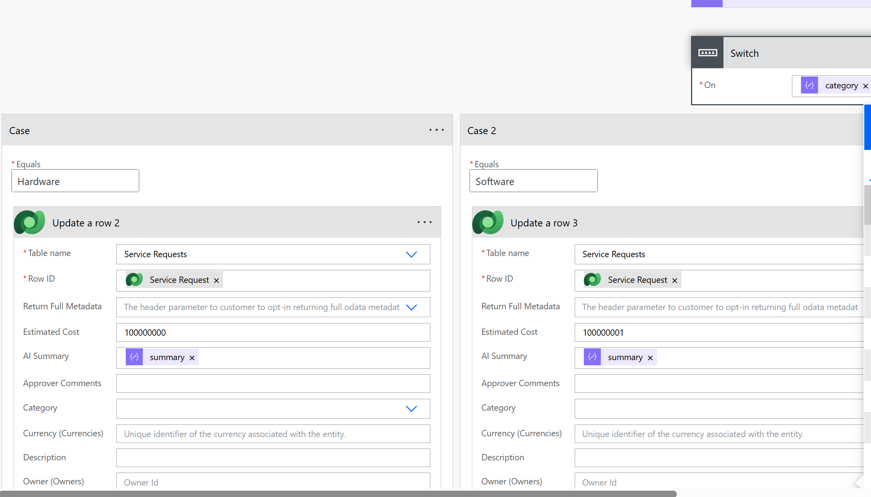

Business rules
New Step Add a Condition. Left side: the trigger's Estimated Cost; operator: is less than or equal to; right side: 10000.
If yes (cost ≤ ₹10,000):
- Update a row: Status = Auto-Processed.
- Send an email (V2) to the requester (see 8.7 for content).
If no (cost > ₹10,000):
- Add a nested Condition: Estimated Cost is greater than 50000.
  - If yes: Update a row, set Priority = High.
  - If no: do nothing (keep AI priority).
- Update a row: Status = Pending Approval.
- Add Start and wait for an approval:
  - Approval type: Approve/Reject - First to respond
  - Title: Service request: followed by the Request Title
  - Assigned to: approver's email (for the lab use your Approver test user)
  - Details (Markdown supported):
**Requester:** Requester Email
**Category:** AI category
**Priority:** priority after rules
**Estimated cost:** ₹ Estimated Cost
**AI summary:** AI summary
**Full description:** Description

Add a Condition on the approval Outcome equals Approve:
  - Yes: Update a row, Status = Approved, Approver Comments = approval responses comments.
  - No: Update a row, Status = Rejected, Approver Comments = approval responses comments.

Notify the employee
Add Send an email (V2) (Office 365 Outlook) after each branch, or once after the condition merges:
- To: Requester Email
- Subject: Your service request "Request Title" is Status text
- Body: include the AI category, priority, final status and approver comments.
Optional: add a Post message in a chat or channel (Microsoft Teams) action for the same notification.

Build the Power Apps Experience

Create the app
- In the solution choose New > App > Canvas app, phone or tablet layout. Name it Service Request App.
- Add the Dataverse table Service Requests as a data source.

Screen 1: Submit Request
Add an Edit form (frmSubmit) with DataSource = Service Requests and fields: Request Title, Description, Estimated Cost.
Add a button Submit with OnSelect:
Patch(
'Service Requests',
Defaults('Service Requests'),
{
'Request Title': txtTitle.Text,
Description: txtDescription.Text,
'Estimated Cost': Value(txtCost.Text),
'Requester Email': User().Email
}
);
Notify("Request submitted. AI is analyzing it now.", NotificationType.Success);
Navigate(scrMyRequests, ScreenTransition.Fade)

Screen 2: My Requests (real-time status)
- Add a vertical Gallery (galRequests) with Items:
SortByColumns(
Filter('Service Requests', 'Requester Email' = User().Email),
"createdon",
SortOrder.Descending
)
- In the gallery template show Request Title, Category, Priority, Estimated Cost and Status.
- Add a status badge label whose Fill depends on status:
Switch(
ThisItem.Status,
'Status (Service Requests)'.'AI Processing', RGBA(0,120,212,1),
'Status (Service Requests)'.'Pending Approval', RGBA(255,170,0,1),
'Status (Service Requests)'.Approved, RGBA(16,124,16,1),
'Status (Service Requests)'.'Auto-Processed', RGBA(16,124,16,1),
'Status (Service Requests)'.Rejected, RGBA(209,52,56,1),
RGBA(128,128,128,1)
)
- Add a Timer control to refresh the data automatically:
  - Duration: 10000
  - AutoStart: true
  - Repeat: true
  - Visible: false
  - OnTimerEnd: Refresh('Service Requests')
This gives near real-time updates every 10 seconds, so the employee sees the status move from AI Processing to Pending Approval to Approved or Rejected without reloading.

Screen 3: Request Details
On gallery selection navigate to a details screen with a Display form showing all fields, including AI Summary and Approver Comments.

Save and publish
Save, publish and share the app with the Requester test user

